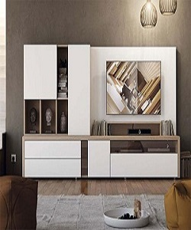

Storage cabinet

$78.43

Availability: In stock

Description

Standard Finish in Black or Extra White Available, for all storing purpose sizes are available with min eight and ten cabinets. This furniture must be fixed to the wall with the enclosed wall fastener. Use fixing devices suitable for the walls in your home.